


User Guide



Introduction
The University uses an online system called Qualtrack for the annual submission of External Examiners’ reports. You will need your UoB login details to access Qualtrack. Work Units, detailing the programmes you are responsible for, are created annually and will be ready for your completion by the time of the final assessment boards. We ask that External Examiners submit their annual report within one month of the final assessment board.
The questions in the report are in-line with QAA requirements and are compliant with OfS B Conditions.
Basic Check List
To access the online system, you will need:
An Internet connection
Your login-in details
A modern/up-to-date Web browser

Your Log-In Details
You should have received an automated email from the University’s IT department informing you that an account has been created for you and giving details on how to login.
The email should have contained details of your Network ID (eg ABC2EXT) and your password. You will not be able to access the system and complete your report without this information. If you have not received these yet or if you have forgotten your login details please contact the Standards & Enhancement Office on eereports@bolton.ac.uk and we will arrange for the information to be sent to you.

A Modern Browser
If you are accessing the system using a laptop or desktop PC it is important that you use an up-to-date Web browser.
We recommend the latest version of Google Chrome, although the latest versions of a Microsoft browser, Firefox and Safari will also work. We have made steps to ensure backwards compatibility with some older Web browsers but you may find that you run into difficulties if you are using anything less than Internet Explorer 9.
Getting Started
You can access the External Examiner Portal (Qualtrack) at any time by logging on to: https://qualtrack.bolton.ac.uk
From here you’ll be able to view any historical reports that you may have already completed along with any current outstanding reports.

Email Notifications
When new reports are published for your attention you will automatically receive an email from Qualtrack. The screenshot below outlines the format of the email:
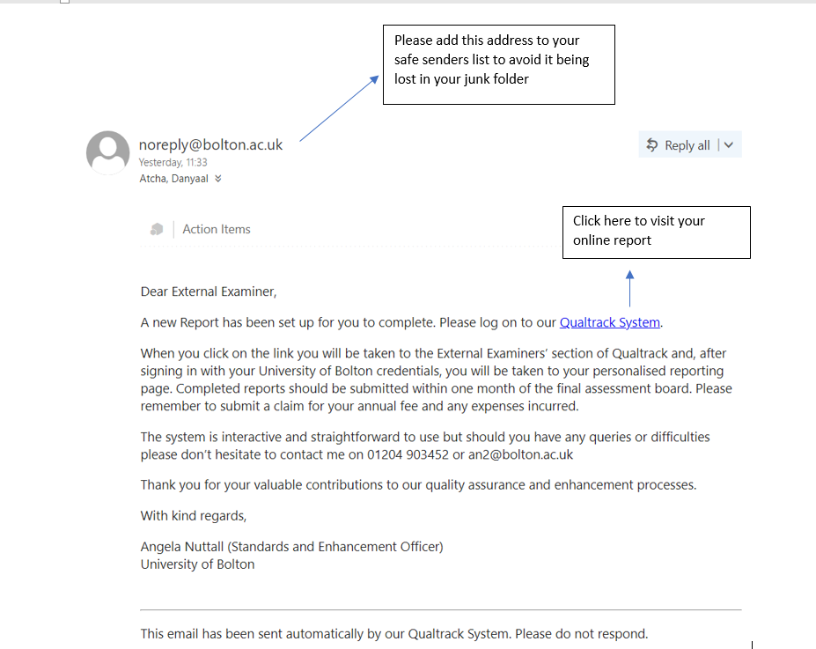

It is very important that these reports are delivered to you, so please make sure that we have your up-to-date contact information. If you have moved institution or changed your contact information for any reason then please let us know as soon as possible.
It might also be a good idea to add noreply@bolton.ac.uk to your safe-senders list to avoid losing the email to your junk folder.
Log in to the System
Clicking on the link to the right-hand side will allow you to log in using your external account. You should use your Network ID for the username and the password sent to you when the account was created, or the one which you have subsequently created.
NOTE:
[Do not confuse your Network ID with your Bolton ID. Your Network ID will contain your initials, usually followed by a number and then ‘EXT’. Your Bolton ID will be a 7 digit number, starting with ‘801’]
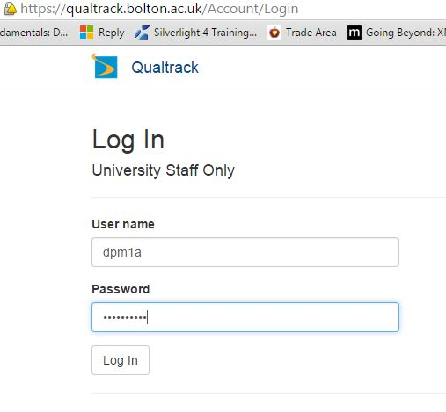

Examiner Overview
Once logged in you will see your ‘Examiner Overview’, here you will be able to view all your External Examiner reports. You will also be able to access and complete your live reports and, in the future, view your previously completed reports.
The screenshot below shows a basic overview screen. It only contains two reports, but over time this may increase.
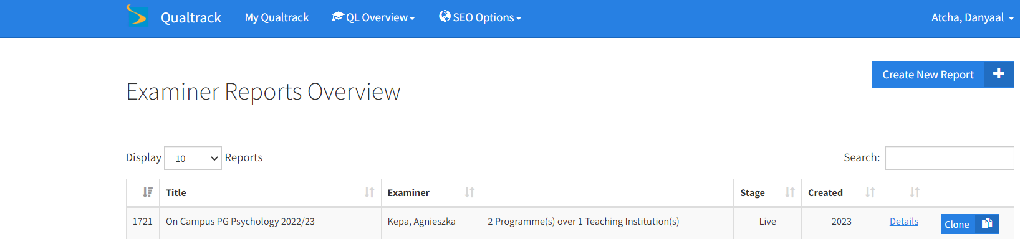
In this example we are asking you to report on two programmes at the same location

This is the title we have given the work unit for admin purposes; it is not the title of the programme

As explained in the screenshot, the title field is the name of the Work Unit, not the programme(s). A report may contain more than one programme (as in the example) but, where those programmes are at the same institution, they are grouped onto the same report.
The illustration shows that the current stage of the report is Live, meaning that it is ready to be completed. To begin completing an External Examiner report click on the details link.
Report Overview
Below is the report overview, the main report consists of three sections (A, B and C) which ask for specific responses to set questions about the programme(s).
Section D is an opportunity for you to raise any matters at an institutional level. Section D also asks for an overview of your tenure if you are completing the report in your final year of office. We are particularly interested in your view of the education gain demonstrated by students throughout the programme.

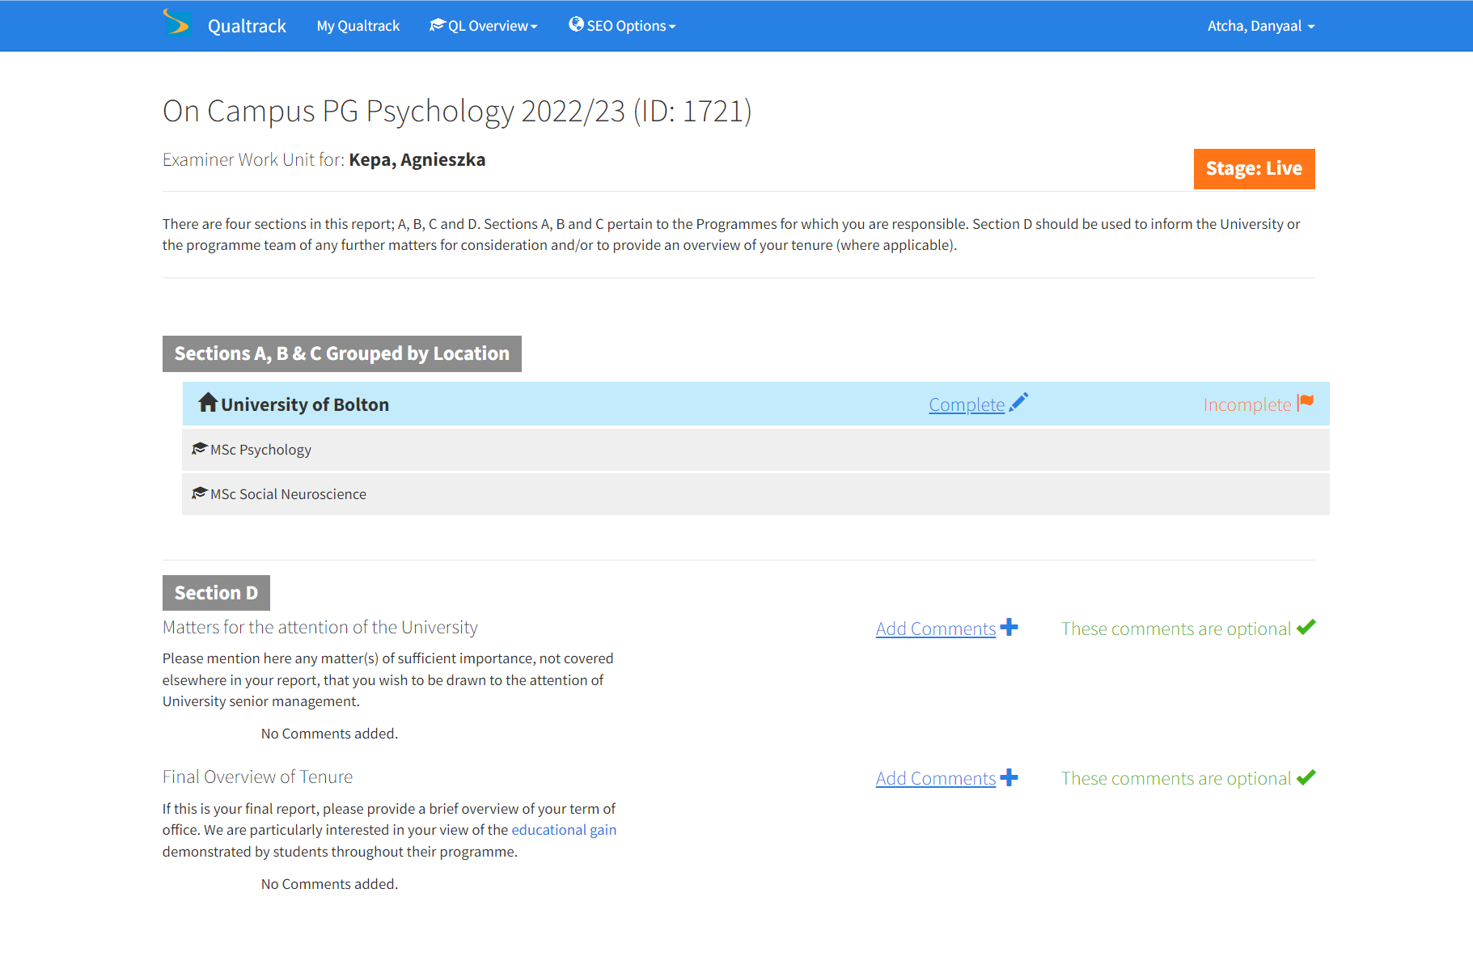

Section A
Clicking on ‘Complete Report’ will take you straight to section A.
For questions 1 and 2, if your response is NO you will need to provide explanatory comments before progressing. Comments following YES responses are also very welcome, particularly in relation to observed good practice and innovation in learning, teaching and assessment, and on the potential to enhance the quality of the learning opportunities provided to students.

Please respond YES if you are substantially in agreement with the question posed.
Please respond NO if you have significant concerns that need to be resolved.
Clicking hyperlinks will direct you to a definitions of key terminology page.
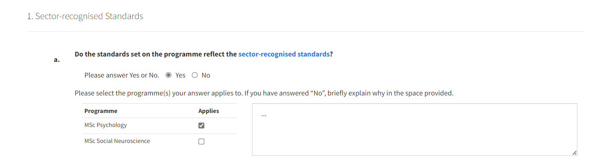

Where an issue is raised, please identify the programme(s) and provide an explanation of the issue

Where there is no issue, no comments are required but are welcomed

As the screenshot illustrates, comments are welcomed but not required if you have clicked YES. However, if you have clicked NO, please indicate to which programme(s) your comments apply and provide some explanatory text of the issue.
Section B
The process for answering questions in Section B works in the same manner as Section A. For questions 3 and 4, if your response is NO you will need to provide explanatory comment before progressing. Comments following YES responses are also very welcome, particularly in relation to observed good practice and innovation in learning, teaching and assessment, and on the potential to enhance the quality of the learning opportunities provided to students.

Please respond YES if you are substantially in agreement with the question posed.
Please respond NO if you have significant concerns that need to be resolved.

Section C
Although the process for answering questions in Section C works in the same way as outlined above, question 5 d iii and iv offer the opportunity to answer Not Applicable, should this be the most appropriate response.
If a NO response is provided to the question below, comments are required before proceeding to the following page
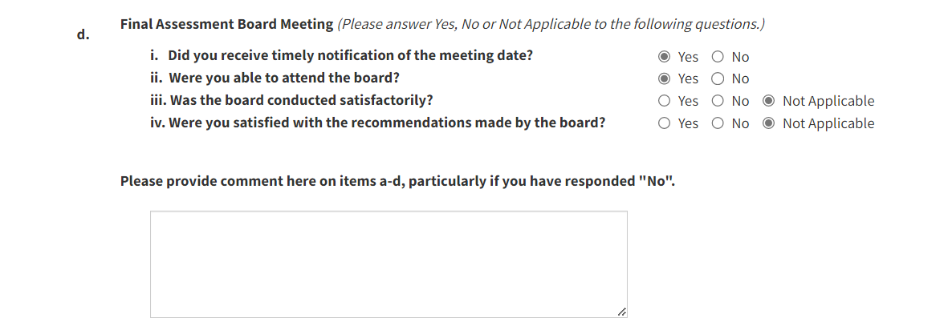
Question 6 – Professional, Statutory or Regulatory Body Status
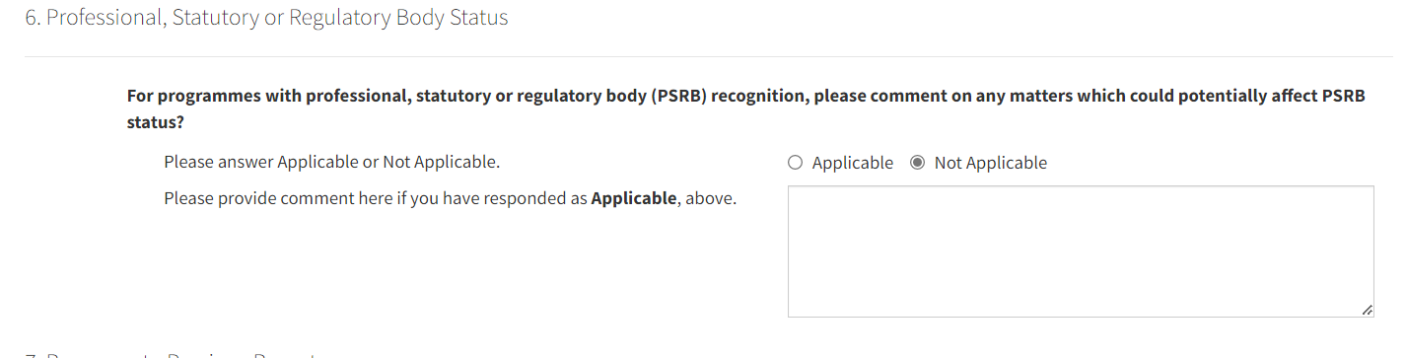
If Applicable has been provided as an answer to question 6, comments are required before proceeding to the following page.
Question 7 – Response to Previous Report
If a NO response has been provided to question 7, comments are required before proceeding to the following page.
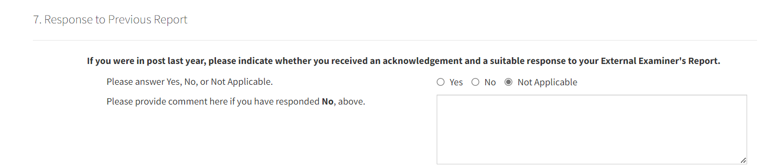
Once sections A, B and C have been completed the status on the work unit will change to Completed.

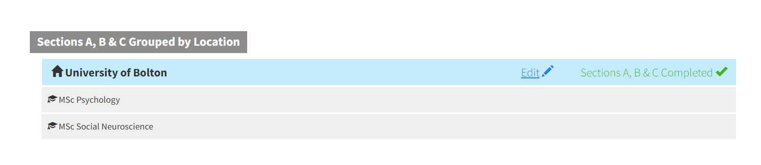

Section D
Section D is designed to highlight any issues (positive or negative) you may want us to consider at an institutional level, ie issues which reflect on the institution as a whole as opposed to being Programme or School specific. Even if there are no issues you would like us to consider it would be helpful if you could simply indicate such, thus confirming that consideration has been given to this aspect.

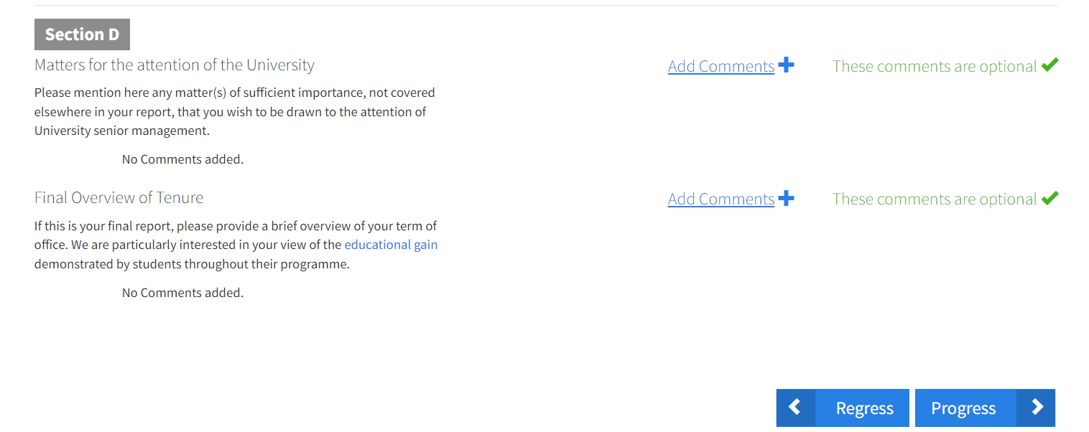
By selecting the add comments option a text box will appear prompting your comments. This is not a compulsory field.

Once the report is complete please press the progress and submit buttons.

After submitting your report you will notice that the status moves to the Quality Review stage. The Standards & Enhancement Office will review your report and either progress it thus making it available to the Programme Leader, others within the School and the wider institution, or seek further clarification from you.
Please be careful not to switch off your device or close your Web browser whilst saving is in progress; there are two indicators that this is happening - buttons on the application will change from ‘Submit’ to ‘Working’ and, depending on your device, you may also see a progress bar.

We hope that you find the University of Bolton’s External Examiner Reporting System an efficient tool. Please remember to submit your annual fee claim on submission of your report by emailing eereports@bolton.ac.uk

