

A Best Practice Guide to Curriculum Design

This document supports the use of innovative programme design of taught programmes at all levels. The guide is divided into 3 main sections:
- Rationale
- The University of Bolton Curriculum Philosophy
- Practical Guidance for Curriculum Design

Section 1: Rationale
The aim of the guide is to ensure that University of Bolton programmes are designed using a unique and highly effective curriculum architecture in order to:
- Provide a distinctive, stimulating and flexible offer which effectively consolidates learning CHOICE, CONSOLIDATION
- Allow for the development of a personalised, coherent, professionally relevant and challenging student learning experience COHORT, CONTEMPORARY, COHERENCE, CHALLENGE
- Enhance student satisfaction
- Improve student achievement and retention
- Improve graduate employment outcomes
- Enhance industry involvement
- Promote the University of Bolton Graduate Attributes Framework (GAME/GAME+)

Teaching Intensive, Research Informed: Accordingly, emphasis is placed on the support and empowerment of tutors to develop innovative and effective learning, teaching and assessment strategies, which are underpinned by cutting edge research and scholarly activity.



Section 2: The University of Bolton Curriculum Philosophy
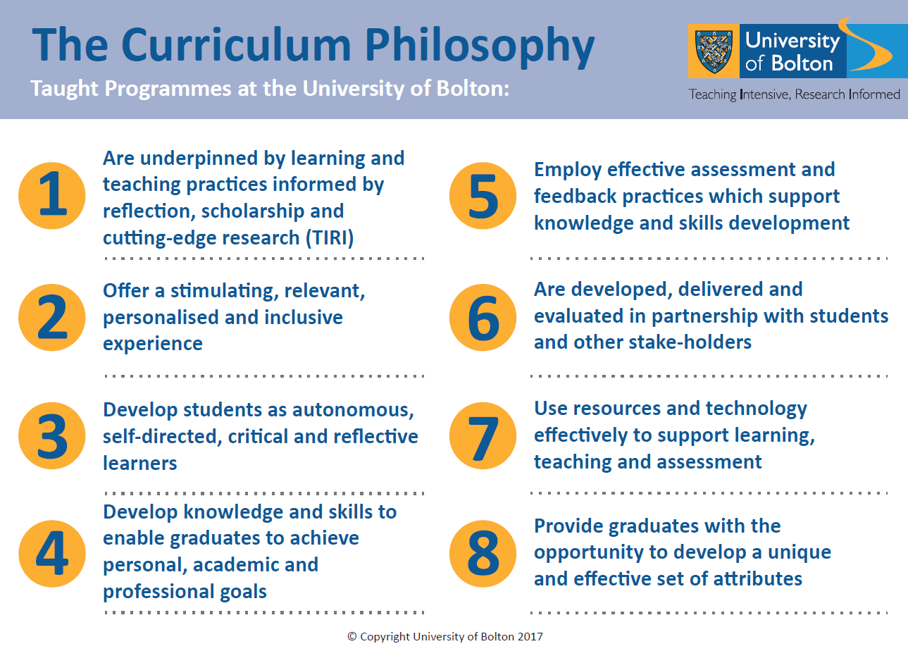

Section 3: Practical Guidelines
Curriculum design takes place at programme approval stage. Please refer also the Guidelines for Preparing Programme Specifications and Guidelines for Preparing Module Specifications.

Component 1: Programmes at the University of Bolton are underpinned by learning and teaching practices informed by reflection, scholarship and cutting-edge research (TIRI) CONTEMPORARY
- Research and scholarly activity should be used to inform curriculum design and delivery methods - to ensure programmes are relevant, up to date and stimulating.
- Allow for flexibility at programme and module level by outlining broad strategies for learning and teaching in programme and module specifications. Examples of learning and teaching methods should be presented, and not a finite list. In this way, academics can adopt delivery methods which are relevant, stimulating and underpinned by educational scholarship and research.
- Consider global challenges including the need for Net Zero/Clean Growth, and the Ageing Society
- Draw on labour market information and feedback from Industry Advisory Boards (IABs) to provide real-world context and an evidence base for skills acquisition.

Component 2: Programmes at the University of Bolton offer a stimulating, relevant, personalised and inclusive experience COHORT & CONTEMPORARY
- When writing programme and module learning outcomes, consider the wording carefully, recognising the diverse nature of the student body, the dynamic external environment and international perspectives.

- Allow for flexibility at programme and module level by outlining broad strategies for learning, teaching and assessment (formative and summative).

- Ensure the programme is professionally relevant, embed formal opportunities for work-related learning e.g. placements, projects, professional discussions, presentations, guest speakers, industry visits etc. Please note: All programmes are expected to include elements of work-related learning

- Embed formal opportunities for setting and reflecting on goals, as well as professional development planning at each stage of the programme.

- Embed formal opportunities for developing knowledge and understanding of the importance of sustainability (economic, social and environmental) and strategies for sustainability in the context of the programme subject.

Component 3: Programmes at the University of Bolton develop students as autonomous, self-directed, critical and reflective learners CHALLENGE

- At each level use appropriate verbs for learning outcomes – demonstrating expectations. e.g: Level 3 and HE4: explain, describe, discuss. HE5: Analyse, appraise, compare and contrast. HE6 and HE7: Critically appraise, critically evaluate, synthesise. HE7 also include: Solve complex problems, develop creative or innovative solutions/recommendations

- At each level make explicit where and how students will develop and reflect on key on academic, professional/practical and life skills within a relevant context. Skills should be embedded in the curriculum and there should be clear progression from dependent to independent learning – culminating in an independent research project.

Examples of academic skills: information literacy, academic writing, referencing, presentation and research skills
Examples of life skills: Logic, analysis, creativity, problem-solving, planning, time-management, flexibility, communication, negotiation, influencing, conflict management, team working, leadership, enterprise, resilience, self-awareness, critical self-reflection.

Component 4: Programmes at the University of Bolton develop knowledge and skills to ensure graduates achieve their personal, academic and professional goals COHERENCE, CONSOLIDATION
- Consider both specialist and interdisciplinary knowledge – informed by Benchmark Statements, Apprenticeship Standards, Industry Advisory Boards, PSRBs (if relevant), current research, as well the present and future needs of industry.

- Plan each curriculum stage carefully and make explicit* how modules support or relate to one another and consolidate learning.
*Develop a visual representation of this in the form of a “Coherence Map”.

- Embed formal opportunities for setting and reflecting on personal, academic and professional goals at each stage of the programme.

- Consider how work-related learning can be integrated effectively into the teaching learning and assessment of a programme. Please note: All programmes are expected to include work-related learning opportunities, such as placements, projects, professional discussions, presentations, guest speakers, industry visits etc. Note: Keep details of specific projects, speakers and visits general on the Programme and Module specifications to allow for flexibility and to ensure CMA guidelines are not breached.

- For programmes with formal off-site learning within an industry setting, a Placement Handbook will need to be provided which includes the roles and responsibilities of the student, academic supervisor and placement provider. See the Code of Practice for Work Based and Placement Learning.

- You may want to consider including an enterprise (or entrepreneurship/intrapreneurship) module in your programme in order to develop creativity, innovation, managed risk-taking and commercial skills.

Component 5: Programmes at the University of Bolton employ effective assessment/ feedback practices which support knowledge and skills development COHERENCE AND CHOICE

- Map the assessment journey of a student throughout the programme to ensure a coherent, varied and planned approach to assessment.

- Select a range of assessment types which effectively consolidate learning – Ensure assessments are authentic, accessible and secure*.

- Where possible/appropriate, describe the method and focus of an assessment a in broad terms on the module specification e.g. academic written piece, oral assessment, practical skills assessment, portfolio of evidence (see below). This will allow students and/or employers to have an input into the nature of assessment set.

- To reduce *academic misconduct and enhance personalisation in assessment consider using one of more of the following strategies
- requiring personal reflection on assessment outcomes
- the use formative assessment point or points to appraise the development
of ideas
- the use of projects and case-studies (authentic, recent and /or local)
- the requirement to consider contemporary legislation, policy and processes

- Use the Industry Advisory Board meetings to check that assessment methodologies are relevant and help to meet the skills needs of relevant industries.

Examples of academic written assessments include: reports, essays, seminar papers, annotated bibliographies, academic journal articles, academic posters, referenced project proposals.
Examples of more practical written assessments include: blogs, trade journal articles, newspaper articles, press releases, reflective diaries, personal/professional development plans, project plans.
Examples of oral assessments include: PowerPoint/Prezi presentations, seminar presentations, poster presentations, role plays, interviews, professional discussions and vivas
Examples of practical skills assessments include: projects, portfolio outputs, OSCEs, performances, + designing artefacts, programmes, tools, resources etc.

Component 6: Programmes at the University of Bolton are developed, delivered and evaluated in partnership with students and other stakeholders
- Current/perspective student opinions must be sought when designing a programme. Group presentations to students are a useful way of outlining discuss key programme features, as well as gaining feedback.

- Potential employer feedback can be sought via email and /or via School Industry Advisory Boards. The draft programme specification together with a brief outline of each module give employers a useful overview.

- Apprenticeship and PSRB standards will also influence curriculum content.

- Ensure that current labour market intelligence is incorporated when designing new programmes. New provision must be based on industry need, addressing future skills deficits.

Component 7: Programmes at the University of Bolton use resources and technology effectively to support learning, teaching and assessment CONTEMPORARY
- A list of contemporary programme learning resources and specialist resources is required at validation.

- It is expected that learning, teaching and assessment is supported by the use of VLE.

- Try not to be too specific about technological resources in the programme and module specifications – in order to future-proof them. Promotional materials can contain details of specific resources, as these can be updated when required.

Component 8: Programmes at the University of Bolton provide graduates with the opportunity to develop a unique and effective set of attributes
- Consider how graduate attributes can be developed at each level e.g. through explicit skills development, diverse assessments, independent and group project-based learning opportunities, work-related learning, authentic business challenges, opportunities for reflection on outcomes and progress, personal development planning, knowledge sharing and peer feedback and support.
- Academics should work together with the Jobs for Students team to provide a sequential approach to career planning and development, adopting the Professional Skills Timeline which supports activity from HE4 – HE6.
- All programmes will incorporate one or more forms of work-based learning for students to gain real-world and industry exposure.

GAME for Undergraduate Programmes
The following 10 core graduate attributes must be embedded in each undergraduate programme of study and serve as the fundamental skills framework for University of Bolton students:
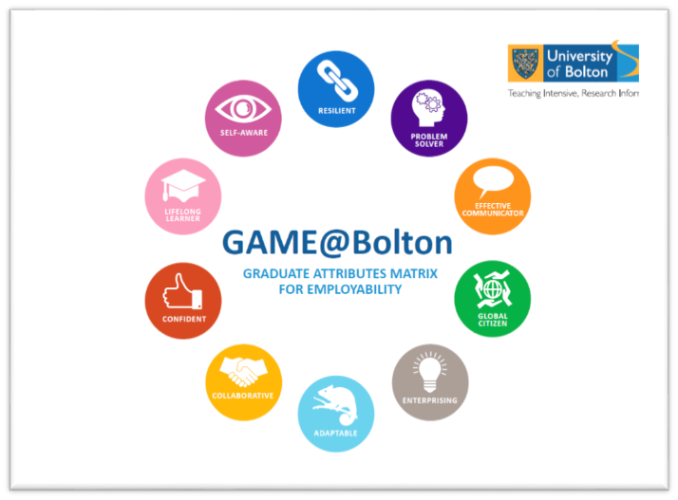

GAME+ for Postgraduate Programmes
Building on the University of Bolton’s undergraduate GAME model, postgraduate students should be supported to develop higher-level skills and attributes. In order to provide a framework for enhanced career velocity, all postgraduate students should work towards GAME+. The five strands of GAME+ are:
• (Critical) Influence and impact
• (Critical) Self-management
• Creativity and innovation
• Professional identity
• Skills mastery.

