DATABASE SCREEN SHOT: | GUIDANCE NOTES:
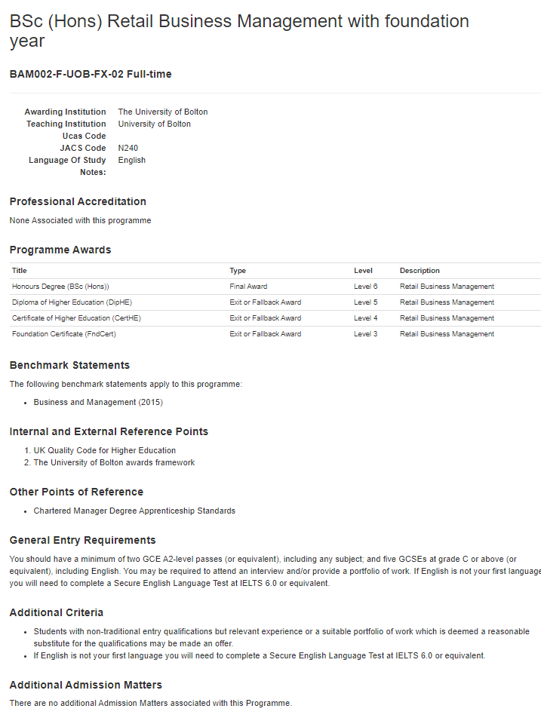 | Programme Code: The Programme Code is generated by the Standards and Enhancement Office (SEO), together with the Programme Specification “shell”, following the planning meeting.
 | Programme Title: Enter the name of the programme – with (Hons) as a prefix if the specification relates to an honours degree. Do not include the qualification letters e.g. FdSc, BDes etc. or the place of delivery in the title. Examples of titles: Business Management, Business Management (HE6 Top Up), Business Management with Foundation Year. For apprenticeship programmes add the name of the apprenticeship standard in brackets after the title. Identify if this is an integrated apprenticeship in the heading.
 | Awarding Institution: This will usually be the University of Bolton
 | Delivering Institution: This will be the University of Bolton unless the programme is delivered by a partner.
 | UCAS Code: Please contact Recruitment and Admissions (Off-campus partners will need to contact their Partnership Co-ordinator).
 | HECOS Code: See: https://www.hesa.ac.uk/collection/c22061/a/hecos
 | Academic Year: Add the start year for the programme
 | Language of Study: This will automatically be filled in as “English”
 | Fitness to Practice: Select either Yes or N/A
 | Professional Accreditation: If the programme is accredited by a professional body then click on “Add New” and select from the drop down menu. If the relevant PSRB is not on the drop down menu, then please contact SEO.
 | Programme Awards: Some standard structures are displayed on the table in Annex 1.
 | Benchmark Statements: Ensure the most up to date QAA Subject Benchmark Statement is identified. See: https://www.qaa.ac.uk/quality-code/subject-benchmark-statements as well as QAA Characteristics Statements. See: https://www.qaa.ac.uk/quality-code/characteristics-statements. Include the date of the statements in brackets after the title of the statement.
 | Internal and External References: Select OfS Sector-Recognised Standards, UK Quality Code for Higher Education and The University of Bolton Awards Framework.
 | Other Points of Reference: If there are any other references, select “Add New” and identify these. For apprenticeship programmes, include the exact name of the apprenticeship standard here.
 | General Entry Requirements: Select the appropriate statement for the programme level and any specific “A” levels and/or GCSEs. If no specific subjects are required, enter “any subject”.
 | Additional Criteria: Identify any non-standard criteria. For apprenticeship programmes include: Degree Apprentices must be employed for a minimum of 30 hours per week and must have the right to live and work in the UK. Applicants must be sponsored by their employer and employed in a relevant role at an appropriate level. A Degree Apprentice cannot be self-employed.
 | Additional Admissions Matters: Select one or more from the following options: DBS, Attend Interview, Portfolio and Industry Experience.
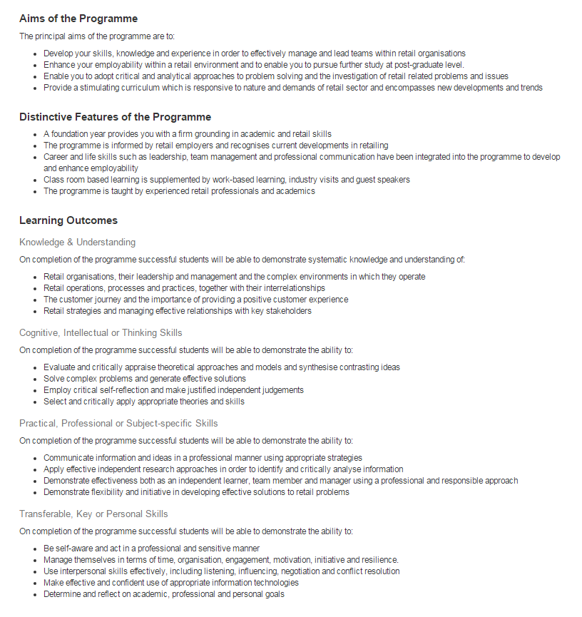 | Aims: Ensure these reflect the nature of the programme. Write in clear and engaging terms. Include necessary content to meet the learning outcomes specified on the Programme Specification and Module Specifications. Start each aim with a verb as these will be displayed under the tag: The principal aims of the programme are to……  + Refer to the University’s Best Practice Guide to Curriculum Design
Distinctive Features of the Programme: Consider the programme’s unique selling points (USPs). Include career and life skills development. Additional features may include:
HE6 Top-up: This is a Top-up programme designed to allow you to progress from a prior approved qualification to an honours level degree. A programme of workshops/induction will support you in the development of honours degree level research approaches and skills.
BSc/BA Hons with Foundation Year: A Foundation year provides you with a firm grounding in academic and xxx skills/underpinning knowledge.
Apprenticeship: +This degree apprenticeship has been developed in line with the apprenticeship standard and industry requirements, which enables the apprentice to apply University learning in the workplace + Apprentices will receive additional support to complete their end-point assessments
Learning Outcomes (LOs): Specify between 4 and 6 LOs for each category.
Refer to the QAA Subject Benchmark Statements, the University’s Best Practice Guide to Curriculum Design and the OfS Sector recognised Standards – Qualification Descriptors: https://www.officeforstudents.org.uk/media/53821cbf-5779-4380-bf2a-aa8f5c53ecd4/sector-recognised-standards.pdf . Ensure Programme LOs are covered by the intended Module LOs.
Knowledge and Understanding: Identify theories, practices and the nature of the environment. These LOs should not contain any verbs as they follow the following tag: On completion of the programme successful students will be able to demonstrate systematic knowledge and understanding of:
Cognitive, Intellectual and Thinking Skills: Start each LO with a verb which is appropriate to the level of the final award. Examples: HE5: Analyse, appraise, compare and contrast, HE6 and HE7: Critically appraise, critically evaluate, synthesise, HE7 also include: Solve complex problems, develop creative or innovative solutions.
These LOs should reflect the level descriptors – See QAA Frameworks for HE Qualifications https://www.qaa.ac.uk/en/quality-code/qualifications-and-credit-frameworks
Practical, Professional and Subject-specific Skills: Start each LO with a verb. These should be appropriate for the nature of the programme and subject.
Transferrable, Key and Personal Skills: Start each LO with a verb. Consider life skills, such as, resilience and initiative, as well as reflection on academic, professional and personal goals. Note: All programmes will have a Transferrable, Key and Personal Skills learning outcome regarding effective verbal and written communication automatically added to the end of the list.
The following document contains some further useful guidance on learning outcomes:
https://s3.eu-west-2.amazonaws.com/assets.creode.advancehe-document-manager/documents/hea/private/writing_learning_outcomes_1568036949.pdf
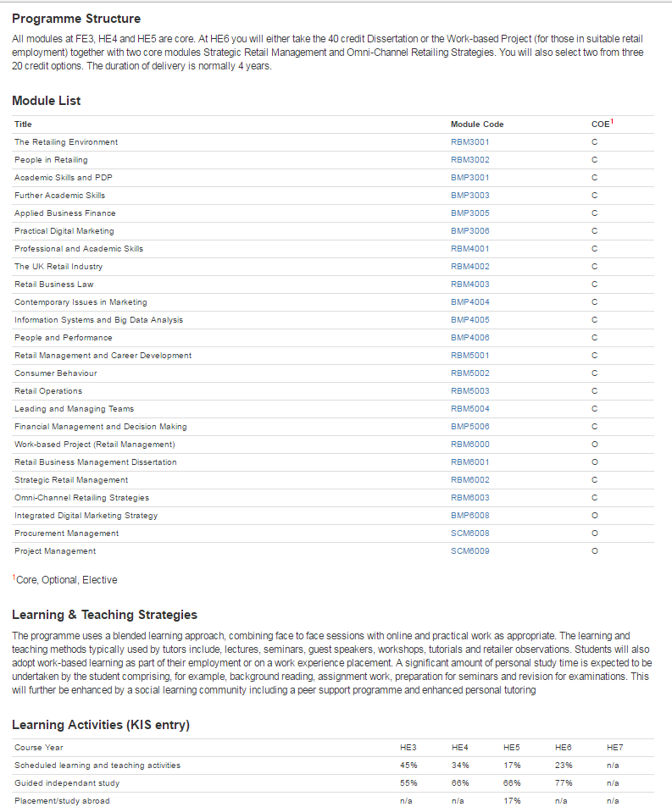 | Programme Structure  An explanation of the programme structure is required for the HEAR (Higher Education Achievement Report). This section should include differentiation between core and any option modules – together with credit requirements for each level including fall-back awards.  Example: This bachelor’s degree programme comprises 360 credits in total, with 120 credits awarded at each level (HE4, HE5 and HE6). All modules at HE4 and HE5 are core. At HE6 there are 3 core modules and a choice of 2 from 3 options. Fall-back awards are given to those students who do not gain the full 360 credits required for the BSc (Hons), as follows: Certificate of Higher Education -120 credits minimum, Diploma of Higher Education -240 credits minimum.  For apprenticeship programmes - Specify the programme length identified in the Standard and reference, identify the period of preparation for the end point assessment, and in the case of integrated degree apprenticeships, any credit assigned to the end-point assessment.
Module List
Add modules in the order you wish them to be displayed on the programme spec. Insert the module code and select whether the module is core or optional. As it is not possible to modify a module once it has been input (it can only be deleted), it is a good idea to rank the modules using odd numbers only. In this way any additional modules can be inserted in the correct place at a later date using an even number.
N.B. The title of the module will only appear once the module specification has been edited on the module database. Do not progress the programme spec until all module titles are displayed.

Learning and Teaching Strategies:
A broad statement here will allow tutors the flexibility to adopt diverse learning and teaching approaches which are stimulating, personalised and inclusive – and which are informed by reflection, evaluation and scholarship.
Refer to the University’s Best Practice Guide to Curriculum Design.
For apprenticeship programmes outline the nature of the apprenticeship experiences and the 80% workplace and 20% off site workshop/lecture split
Learning Activities (KIS entry)
Here you will manually need to calculate the % of scheduled learning and teaching activities, guided independent study and placement learning drawing on the Module Specification hours. Ensure the totals at each level add up to 100%.
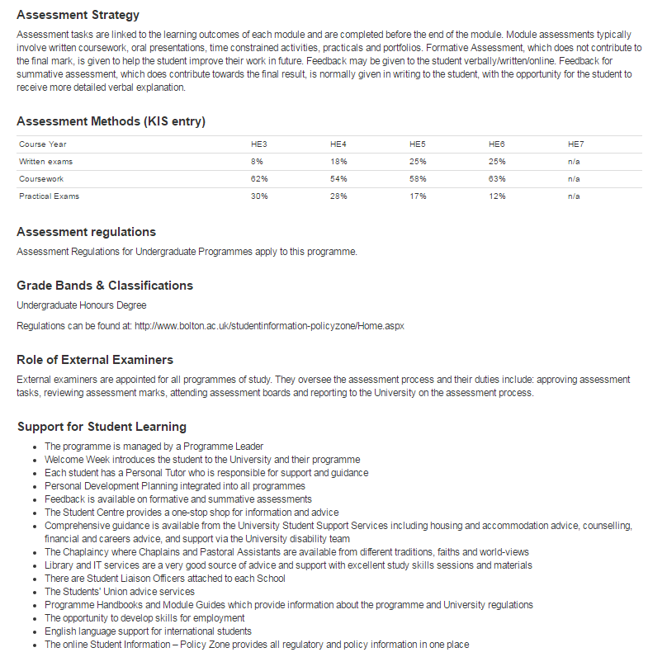  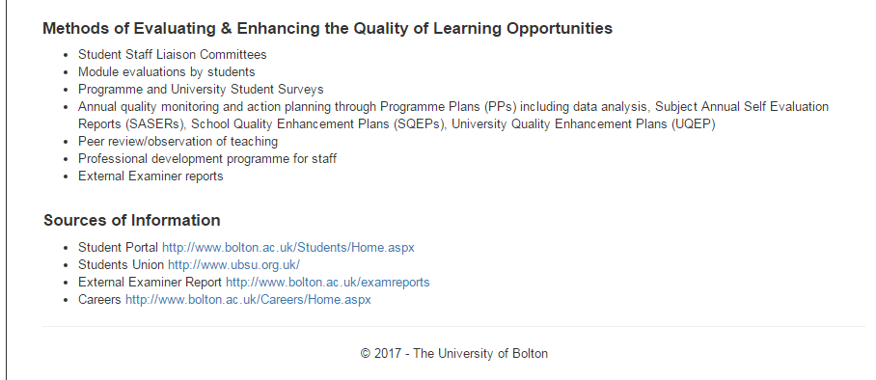 | Assessment Strategy: Here a brief summary of the programme’s assessment strategy is provided. To allow for flexibility, it is advised to provide general details on formative and summative assessment, as well as assessment feedback.  Refer to the University’s Best Practice Guide to Curriculum Design  For apprenticeship programmes outline any learning log/portfolio requirements and the nature of the end-point assessment in the case of integrated degree apprenticeships.
 | Assessment Methods (KIS entry): Here you will manually need to calculate the % of written exams, coursework and practical exams/assessments by drawing on the Module Specification percentages. Ensure the totals at each level add up to 100%.
Assessment Regulations: Select one from
- Assessment Regulations for Undergraduate Programmes
- Assessment Regulations for Postgraduate Programmes
- Other Regulations*
*If there are supplementary regulations, for example from professional bodies then select “Other Regulations” and provide a web-link to the regulations.
 | Grade Bands and Classifications: Select the type of programme from the menu.
 | Role of External Examiners: The text here is pre-entered.
Support for Student Learning:
General Support: Select the support mechanisms which apply from the list presented. Items 9-12 relate to off campus provision
Programme Specific Support: Any other support methods should be added here. Ensure this support will be available year-on-year – and that it is explained in the Programme Handbook.
For apprenticeship programmes include Apprentices are supported in the workplace by an assigned mentor who supplies support, advice and guidance on apprenticeship requirements for the duration of the apprenticeship.
Methods of Evaluating and Enhancing the Quality of Learning Opportunities:
General Methods: Select the methods which apply from the list presented (normally everything listed).
Programme Specific Methods: Any other methods should be added here. For apprenticeship programmes add Self-assessment Reports and Quality Improvement Plans
Sources of Information:
Information Generic Sources of: Select the methods which apply from the list presented For On-Campus programmes this is normally everything listed. For Off-Campus and online programmes some options might not be relevant.
Custom Sources of Information: Add any other sources of information, together with a web-link. For Off-Campus programmes, add the partner website as a minimum. For apprenticeship programmes include a link to the relevant standard and end-point assessment.

Annex 1: Programme Awards: Examples of Standard Programme Structures
 | Foundation Degree | Standard honours degree | Honours degree + Foundation Year | Honours degree – HE6 Top-up | Master’s Degree
Award | Foundation Degree | Honours Degree | Honours Degree | Honours Degree | Master’s Degree
Award | FdA/FdSc | BSc/BA/BSc/LLB/BEd/BEng | BSc/BA/BSc/LLB/BEd/BEng | BSc/BA/BSc/LLB/BEd/BEng | MA/MSc/MBA/MEd/LLM/  MMath/MDes
Title | Subject only | Subject only | Subject only | Subject only | Subject only
Type | Final Award | Final Award | Final Award | Final Award | Final Award
Level | HE5 | HE6 | HE6 | HE6 | HE7
Award | Certificate of Higher Education | Diploma of Higher Education | Diploma of Higher Education |  | Postgraduate Diploma
Award | Cert HE | Dip HE | Dip HE |  | PgDip
Title | Subject only | Subject only | Subject only |  | Subject only
Type | Exit or Fall-back Award | Exit or Fall-back Award | Exit or Fall-back Award |  | Exit or Fall-back Award
Level | HE4 | HE5 | HE5 |  | HE7
Award |  | Certificate of Higher Education | Certificate of Higher Education |  | Postgraduate Certificate
Award |  | Cert HE | Cert HE |  | PgCert
Title |  | Subject only | Subject only |  | Subject only
Type |  | Exit or Fall-back Award | Exit or Fall-back Award |  | Exit or Fall-back Award
Level |  | HE4 | HE4 |  | HE7
Award |  |  | Foundation Certificate
Award |  |  | FndCert
Title |  |  | Subject only
Type |  |  | Exit or Fall-back Award
Level |  |  | Fd Year/Access/Level 3

